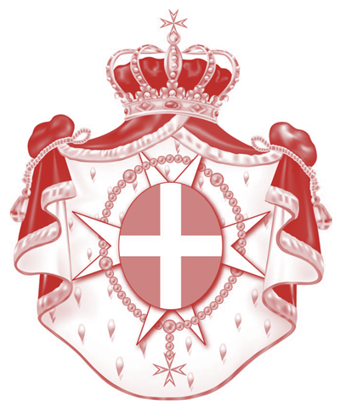
Sovereign Military Hospitaller Order
of St. John of Jerusalem of Rhodes and of Malta
_____
Permanent observer Mission to the United Nations office
and other International Organizations in Geneva

Human Rights Council – 53rd session
Item 2-Interactive dialogue with the Independent International Commission of Inquiry on the Occupied Palestinian Territory, including East Jerusalem, and Israel

Statement by H.E. Ambassador Marie-Thérèse Pictet-Althann
20 June 2023

Mr. President,
Mr. High Commissioner,
Excellencies, Distinguished Delegates,

The Sovereign Order of Malta welcomes the Independent International Commission’s report on the OPT, including East Jerusalem, and Israel and shares many of its concerns.

The Commission’s findings regarding the violations on the right to health are particularly disturbing in view of the Order of Malta’s long standing medical and healthcare assistance throughout the region. Its Holy Family Hospital in Bethlehem is responsible for the delivery of over 70% of all children being born in the area. Since 1990 the Hospital’s staff has aided with the delivery of over 90 000 babies of all faiths. However, in the present tense situation and due to the general lack of safety, our ambulances encounter serious difficulties in reaching the hospital, our mobile clinics are unable to deliver adequate health services and the protection of our medical health staff in Palestine is not guaranteed.

We welcome the Report’s recommendation to repeal laws and provisions that obstruct the work of civil society, including laws imposing unnecessary and unreasonable financial, procedural, and technical barriers The continuance of such laws has a grave impact on the operational capability of our hospital and the residents of the greater Bethlehem community that are dependant on the medical services provided.

Our Delegation also wishes to draw the Commission’s attention to issues regarding freedom to practice religion when believers are denied access to Christian places of worship. We should always remember that freedom of religion or belief is a universal human right.

Thank you.

3, PLACE CLAPARÈDE – CH-1205 GENEVA – TELEPHONE: 0041 (0)22 346 86 87
E.MAIL: UNMISSIONGENEVA@ORDEROFMAlTA.INT- HTTPS://UNMISSIONGE.ORDEROFMALTA.INT/EN/

